**Admin mode**

* **Authentication;**

Admin part is different from InstructorAuthentication and Student Authentication. Admin should enter the different uml. In this page, admin can login on system with username and password. Password is given by the system database.

* **Edit appointment information;**

Admin update information which must be change, like change instructors passwords or instructor authority.

* **List Instructors;**

Admin can see instructors list .In this list, Admin can add and delete operations.

* **Approve Request of Instructors;**

Instructors can send request for authorize. Admin can see requests which come from Instructors to take authorize Instructors account.

* **Add New Instructors;**

Instructor who want to make exam authorized by Admin to the System.

* **Delete Instructors;**

Admin update which is necessary such as a instructor arrive the school.

* **Save;**

Admin record all Instructors on the system when he or she entered all informations.

* **Log Off;**

Admin exit the system when they finished the operations on the system.

## System Models

Describe the scenarios, use cases, object model, and dynamic models for the system. This section contains the complete functional specification, including mock-ups illustrating the user interface of the system and navigational paths representing the sequence of screens.

* ***Scenarios***

## Scenario 1

|  |
| --- |
| **Scenario name:** Login Admin |
| **Participant actor instances: Admin:Çağla** |
| **Flow of events:**   1. Firstly Çağla writes ExaminationSystem/admin on browser. 2. Çağla sees login pages and she enter UserName into UserName text field also enter password into Password text field on this pages.   a) if Çağla leaves one or more fields empty, system displays a warning message, like "This area can not be empty.".   1. If UserName,password and role match to information which are in Online Exam database Çağla can login to the Online Exam System.   a)If the informations checked from database are not true, system displays a warning message, like "Wrong username or password, please retry.". |

## Scenario 2

|  |
| --- |
| **Scenario name:** Adding Instructor |
| **Participant actor instances: Admin: Çağla Instructor:Güney** |
| **Flow of events:**   1. Çağla hears that Güney want to make exam in the Online Exam system. 2. Firstly Çağla logs into the Online Exam System. 3. Çağla selects “Add New Instructor” button. 4. Çağla fills the related field with the personal information of the Güney. 5. Then Çağla click “save” button. 6. OnlineExam save the Güney’s personal informations on database . 7. Çağla sees a "Saved successfully" message on screen.Then Çağla logs of. |

|  |
| --- |
| **Scenario name:** Deleting Instructor |
| **Participant actor instances: Admin:**Çağla **Instructor:**Güney |
| **Flow of events:**   1. Çağla hears that Güney leave the school and want to delete his account. 2. Firstly Çağla logs into the ES. 3. Çağla selects “Delete Instructor” button 4. She sees all Instructors who registered in the system. 5. Çağla chooses Güney. 6. Then Çağla click “delete and save” button. 7. OnlineExam finds the Güney on database and delete her all informations on system. 8. The message shown on screen that “The instructor is deleted successfully”. 9. Çağla logs of. |

## Scenario 3

## Scenario 4

|  |
| --- |
| **Scenario name:** ListInstructors |
| **Participant actor instances: Admin:**Çağla |
| **Flow of events:**   1. Firstly Çağla logs into the ES. 2. Çağla clicks the "List Instructors" button on administrator main page. 3. She sees all Instructors who registered in the system. 4. Çağla clicks "Back" button. 5. The system directs administrator to his/her main page. 6. Çağla logs of. |

## Scenario 5

|  |
| --- |
| **Scenario name:** EditInstructorInformations |
| **Participant actor instances: Admin:**Çağla |
| **Flow of events:**   1. Firstly Çağla logs into the ES. 2. Çağla selects a instructor that is going to be editted. 3. Çağla clicks the "Edit Instructor Informations" button. 4. Çağla changes necessary areas with the instructor information of the selected instructor. 5. Çağla clicks the "Save" button. 6. She see a "Saved successfully!" message on a dialogue box. 7. Çağla logs of. |

## Scenario 6

|  |
| --- |
| **Scenario name:** ApproveRequestofInstructor |
| **Participant actor instances: Admin:**Çağla Instructor:Güney |
| **Flow of events:**   1. Firstly Güney logs into the ES. 2. Güney send request to be instructor to Çağla. 3. Çağla clicks the "Request of Instructors" button. 4. Çağla sees List of Requests of Instructors. 5. Çağla choose Güneys name and click Approve button. 6. Çağla clicks the "Save" button. 7. She see a "Saved successfully!" message on a dialogue box. 8. Çağla logs of. |

## Scenario 7

|  |
| --- |
| **Use case name:** Logout |
| **Participant actor instances: Admin:**Çağla |
| **Flow of events:**   1. Çağla clicks "Logout" button. 2. System redirects administrator to the login page. |

**Use case 1:**

|  |
| --- |
| **Use case name:** Login |
| **Participant actors:** Initiated by Administrator |
| **Flow of events:**   1. Administrator displays the login screen of the application. 2. Administrator enters username and password to the related areas. 3. Administrator clicks "Login" button. 4. System checks the informations from database. 5. System fetches the main screen of administrator. |
| **Entry Condition:** 1. Administrator displays the login screen of the system.  Administrator saves his/her informations to the database. |
| **Exit Condition:** Administrator clicks "Login" button and system displays the administrator main page. |
| **Quality Requirements**: 2*. If administrator leaves one or more fields empty, system displays a warning message, like "This area can not be empty.".  4*. If the informations checked from database are not true, system displays a warning message, like "Wrong username or password, please retry.". |

**Use case 2:**

|  |
| --- |
| **Use case name:** ListInstructors |
| **Participant actors:** Initiated by Administrator |
| **Flow of events:**   1. Administrator clicks the "List Instructors" button on administrator main page. 2. System fetches the screen which list of personnels can be displayed. 3. Administrator clicks "Back" button. 4. The system directs administrator to his/her main page. |
| **Entry Condition:** Administrator logs in to the Examination System.  Administrator displays his/her main page. |
| **Exit Condition:** Administrator clicks "Back" button and system directs administrator to his/her main page. |
| **Quality Requirements:** None. |

**Use case 3:**

|  |
| --- |
| **Use case name:** AddNewInstructor |
| **Participant actors:** Initiated by Administrator |
| **Flow of events:**   1. Administrator clicks "Add New Instuctor" button. 2. System fetches the screen that new personnel can be added. 3. Administrator fills the related areas with the personal information of the new instructor.   a) If administrator leaves a field empty, system displays a warning message, like "This area can not be empty.".   1. Administrator clicks "Save" button.   a) If administrator closes the page without saving, system does not save the informations.   1. System saves the new instructor and his/her informations to the database. 2. System displays a "Saved successfully!" message on a dialogue box.   a) If system fails to save informations to the database, it displays a "saving is unsuccessful" message   1. System redirects administrator to the administrator main page. |
| **Entry Condition:** Administrator logs in to the Examination System.  Administrator displays his/her main page. |
| **Exit Condition:** System saves the new personnel and his/her informations to the database, then system displays a "Saved successfully!" message and system redirects administrator to the administrator main page. |
| **Quality Requirements:** 3*. If administrator leaves a field empty, system displays a warning message, like "This area can not be empty.".  4*. If administrator closes the page without saving, system does not save the informations.  6*. If system fails to save informations to the database, it displays a "saving is unsuccessful" message. |

**Use case 4:**

|  |
| --- |
| **Use case name:** DeleteInstructor |
| **Participant actors:** Initiated by Administrator |
| **Flow of events:**   1. Administrator selects a instroctor that is going to be deleted.   a) If administrator does not select a instructor from instructor list, system displays a warning message, like "A selection must be done to delete"   1. Administrator clicks the "Delete Instructor" button. 2. System deletes the selected instructor record from database. 3. System displays a "Deleted successfully!" message on a dialogue box.   a) If system fails to delete informations from the database, it displays a "deleting is unsuccessful" message.   1. System reloads the instructor list screen. |
| **Entry Condition:** . 1.Administrator logs in to the Examination System.  2. Administrator displays the screen that list of personnels is displayed. |
| **Exit Condition:** System displays a "Deleted successfully!" message and system reloads the personnel list screen. |
| **Quality Requirements:** 1*. If administrator does not select a personnel from personnel list, system displays a warning message, like "A selection must be done to delete".  4*. If system fails to delete informations from the database, it displays a "deleting is unsuccessful" message. |

**Use case 5:**

|  |
| --- |
| **Use case name:** EditInstructorInformations |
| **Participant actors:** Initiated by Administrator |
| **Flow of events:**   1. Administrator selects a instructor that is going to be editted.   a) If administrator does not select a instructor from instructor list, system displays a warning message, like "A selection must be done to edit".   1. Administrator clicks the "Edit Instructor Informations" button. 2. System fetches the screen that displays the informations of selected personnel. 3. Administrator changes necessary areas with the instructor information of the selected instructor.   a) If administrator leaves a field empty, system displays a warning message, like "This area can not be empty.".   1. Administrator clicks the "Save" button.   a) If administrator closes the page without saving, system does not save the informations.   1. System saves the changes to the database. 2. System displays a "Saved successfully!" message on a dialogue box.   a) If system fails to save informations to the database, it displays a "saving is unsuccessful" message.   1. System redirects administrator to the administrator main page. |
| **Entry Condition:** Administrator logs in to the Examination System.  Administrator displays the screen that list of personnels is displayed. |
| **Exit Condition:** System saves the changes to the database and displays a "Saved successfully!" message, then redirects administrator to the administrator main page |
| **Quality Requirements:** 1*. If administrator does not select a instructor from instructor list, system displays a warning message, like "A selection must be done to edit".  4*. If administrator leaves a field empty, system displays a warning message, like "This area can not be empty.".  5*. If administrator closes the page without saving, system does not save the informations.  7*. If system fails to save informations to the database, it displays a "saving is unsuccessful" message. |

**Use case 6:**

|  |
| --- |
| **Use case name:** ApproveRequestofInstructor |
| **Participant actor instances:** Initiated by Administrator |
| **Flow of events:**   1. Administor clicks the "Request of Instructors" button. 2. System show List of Requests of Instructors. 3. Administor choose instructor name and click "Approve" button. 4. Administor clicks the "Save" button. 5. System show a "Saved successfully!" message on a dialogue box. |
| **Entry Condition:** Administrator logs in to the Examination System.  Administrator displays his/her main page. |
| **Exit Condition:** Administrator clicks "Logout" button and system redirects administrator to the login page. |
| **Quality Requirements:** 3* If administrator does not sellect any request of instructor, and click approve system displays a warning message, like "You should choose a request".  5*. If administrator closes the page without saving, system does not save the informations.  6*. If system fails to save informations to the database, it displays a "saving is unsuccessful" message. |

**Use case 7:**

|  |
| --- |
| **Use case name:** Logout |
| **Participant actors:** Initiated by Administrator |
| **Flow of events:**   1. Administrator clicks "Logout" button. 2. System redirects administrator to the login page. |
| **Entry Condition:** Administrator logs in to the Examination System.  Administrator displays his/her main page. |
| **Exit Condition:** Administrator clicks "Logout" button and system redirects administrator to the login page. |
| **Quality Requirements:** None. |

LoginAdmin

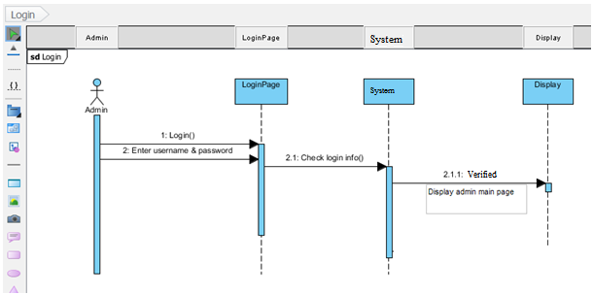

Add new Instructor

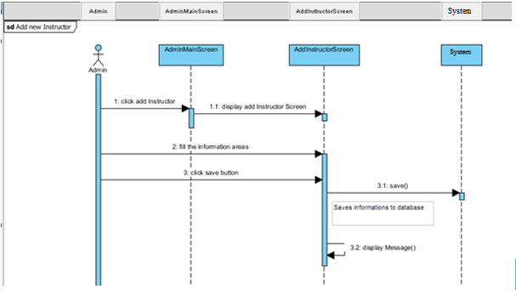

List and edit and delete Instructor

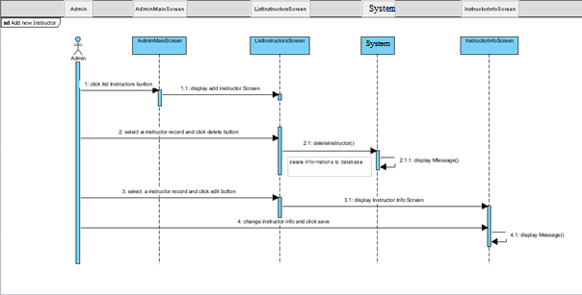

Request of Instructor

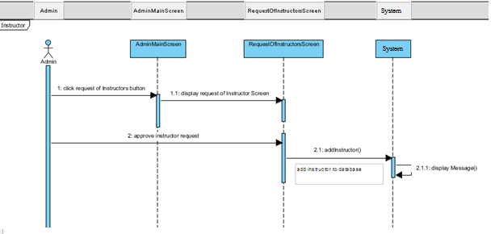

# Activity Diagram

Activity Diagram

Admin mode

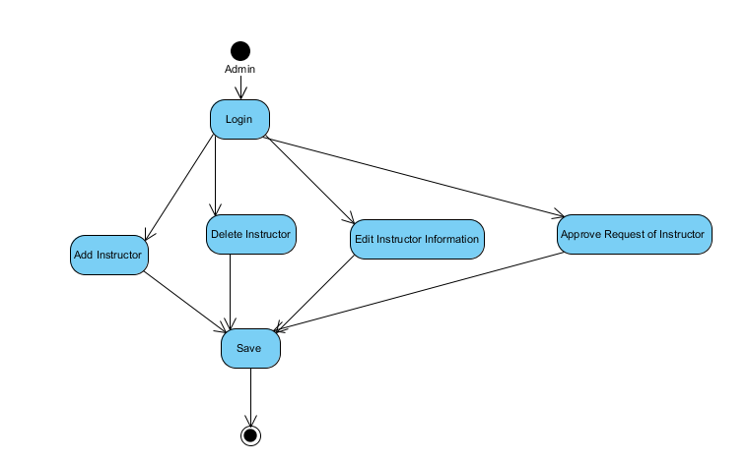

# Glossary

**Actor:** External entity that needs to exchange information with the system. An actor can represent either a user role or another system. In other words; a person, software system, or hardware device that interacts with a system to achieve a useful goal.

**Analysis:** An activity during which developers ensure that the system requirements are correct, complete, consistent, unambiguous, and realistic.

**Authentication:** The process of associating a person with access rights.

**Class diagram:** UML notation representing the structure of the system in terms of objects, classes, attributes, operations, and associations. Class diagrams are used to represent object models during development.

**Functional Requirement:** An area of functionality the system must support. The functional requirements describe the interactions between actors and the system independent of the realization of the system.

**Login:** Procedure used to get access to an operating system, or application, usually in a remote computer.

**Nonfunctional Requirement:** A user visible constraint on the system. Nonfunctional requirements describe user visible aspects of the system that are not directly related with the functionality of the system.

**Class:** A description of a set of objects having common properties and behaviors, which typically correspond to real-world items (persons, places, or things) in the business or problem domain.

**Exception:** A condition that prevents a use case from successfully concluding. The use case’s post conditions are not reached and the actor’s goal is not satisfied.

**Scenario:** A description of a specific interaction between a user and a system to accomplish some goal. An instance of usage of the system. Often presented in the form of a story.

**Sequence Diagram:** An analysis model that shows the order in which messages passes in a system or the chronological sequence of steps that take place in an activity and the entities or classes involved in the activity.

**Unified Modeling Language:** UML is a modeling language used to define a system prior to construction, much like a blueprint is used prior to building a house. It allows the project team to specify, visualize, and document an application, including its structure and design, in a way that meets all of the user requirements.

**Use Case:** A description of an interaction between an actor and a system that results in an outcome that provides value to the actor.

**Use Case Diagram:** An analysis model that identifies the actors who can interact with a system to accomplish valuable goals and the various use cases that each actor will perform.

**Online Examination System**: Students use the system to join exam aminations which is prepared by the instructor.

**Instructor:** Instructors prepare exam in the system and they record students of class on the system. Also they can see students exam results.

**Student:** Students take examination on the System. They can see their exam results.

**Admin:**  Admin give the authority to instructor to create exam. It can delete ,edit and add instructor to the system.